Diagnosing Bias vs. Variance

In this section we examine the relationship between the degree of the polynomial d and the underfitting or overfitting of our hypothesis.

* We need to distinguish whether **bias** or **variance** is the problem contributing to bad predictions.
* High bias is underfitting and high variance is overfitting. Ideally, we need to find a golden mean between these two.

The training error will tend to **decrease** as we increase the degree d of the polynomial.

At the same time, the cross validation error will tend to **decrease** as we increase d up to a point, and then it will **increase** as d is increased, forming a convex curve.

**High bias (underfitting)**: both *Jtrain*​(Θ) and *JCV*​(Θ) will be high. Also, *JCV*​(Θ)≈*Jtrain*​(Θ).

**High variance (overfitting)**: *Jtrain*​(Θ) will be low and *JCV*​(Θ) will be much greater than *Jtrain*​(Θ).

The is summarized in the figure below:

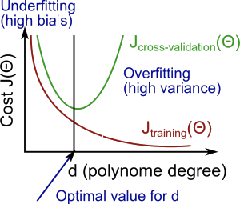

Regularization and Bias/Variance

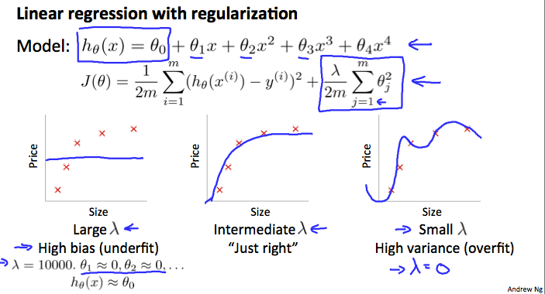

In the figure above, we see that as *λ* increases, our fit becomes more rigid. On the other hand, as *λ* approaches 0, we tend to over overfit the data. So how do we choose our parameter *λ* to get it 'just right' ? In order to choose the model and the regularization term λ, we need to:

1. Create a list of lambdas (i.e. λ∈{0,0.01,0.02,0.04,0.08,0.16,0.32,0.64,1.28,2.56,5.12,10.24});
2. Create a set of models with different degrees or any other variants.
3. Iterate through the *λ*s and for each *λ* go through all the models to learn some Θ.
4. Compute the cross validation error using the learned Θ (computed with λ) on the *JCV*​(Θ) **without** regularization or λ = 0.
5. Select the best combo that produces the lowest error on the cross validation set.
6. Using the best combo Θ and λ, apply it on *Jtest*​(Θ) to see if it has a good generalization of the problem.

Learning Curves

Training an algorithm on a very few number of data points (such as 1, 2 or 3) will easily have 0 errors because we can always find a quadratic curve that touches exactly those number of points. Hence:

* As the training set gets larger, the error for a quadratic function increases.
* The error value will plateau out after a certain m, or training set size.

**Experiencing high bias:**

**Low training set size**: causes *Jtrain*​(Θ) to be low and *JCV*​(Θ) to be high.

**Large training set size**: causes both *Jtrain*​(Θ) and *JCV*​(Θ) to be high with *Jtrain*​(Θ)≈*JCV*​(Θ).

If a learning algorithm is suffering from **high bias**, getting more training data will not **(by itself)**help much.

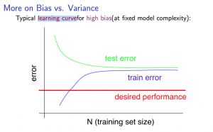

**Experiencing high variance:**

**Low training set size**: *Jtrain*​(Θ) will be low and *JCV*​(Θ) will be high.

**Large training set size**: *Jtrain*​(Θ) increases with training set size and *JCV*​(Θ) continues to decrease without leveling off. Also, *Jtrain*​(Θ) < *JCV*​(Θ) but the difference between them remains significant.

If a learning algorithm is suffering from **high variance**, getting more training data is likely to help.

# Deciding What to Do Next Revisited

Our decision process can be broken down as follows:

* **Getting more training examples:** Fixes high variance
* **Trying smaller sets of features:** Fixes high variance
* **Adding features:** Fixes high bias
* **Adding polynomial features:** Fixes high bias
* **Decreasing λ:** Fixes high bias
* **Increasing λ:** Fixes high variance.

### **Diagnosing Neural Networks**

* A neural network with fewer parameters is **prone to underfitting**. It is also **computationally cheaper**.
* A large neural network with more parameters is **prone to overfitting**. It is also **computationally expensive**. In this case you can use regularization (increase λ) to address the overfitting.

Using a single hidden layer is a good starting default. You can train your neural network on a number of hidden layers using your cross validation set. You can then select the one that performs best.

**Model Complexity Effects:**

* Lower-order polynomials (low model complexity) have high bias and low variance. In this case, the model fits poorly consistently.
* Higher-order polynomials (high model complexity) fit the training data extremely well and the test data extremely poorly. These have low bias on the training data, but very high variance.
* In reality, we would want to choose a model somewhere in between, that can generalize well but also fits the data reasonably well.